AWS SQS, AWS MQ & Secrets Manager
AWS SQS :
Amazon SQS (Simple Queue Service) is a fully managed message queuing service that enables applications, microservices, and distributed systems to communicate asynchronously. It allows one application (Producer) to send messages to a queue, where another application (Consumer) retrieves and processes them independently.
SQS improves scalability, reliability, and fault tolerance by decoupling application components.

SQS :
Without SQS:
Application A --------> Application B
If Application B fails, Application A also fails.
With SQS:
Application A
|
V
+--------------+
| SQS Queue |
+--------------+
|
V
Application B
If Application B is unavailable, messages remain in the queue until it becomes available.

Features
- Fully Managed Service
- Unlimited Scalability
- High Availability
- Secure (IAM + KMS Encryption)
- Message Retention (1 minute–14 days)
- Long Polling
- Dead Letter Queue (DLQ)
- Visibility Timeout
- Message Delay
- Pay only for requests

Components
Producer
Sends messages to SQS.
Examples:
- EC2
- Lambda
- Web Application

Queue
Stores messages temporarily.

Consumer
Reads and deletes messages from the queue.

Queue Types
Standard Queue
- Unlimited throughput
- At least once delivery
- Best-effort ordering
Suitable for:
- Logging
- Image Processing
- Big Data

FIFO Queue
- First In First Out
- Exactly Once Processing
- Ordered Messages
Suitable for:
- Banking
- Financial Transactions
- Order Processing

Important Concepts
Message Retention
Default: 4 Days
Range:
1 Minute → 14 Days

Visibility Timeout
Once a consumer reads a message, it becomes invisible to other consumers.
Default:
30 Seconds

Long Polling
Reduces empty responses and cost.
Default polling:
Short Polling
Recommended:
Long Polling

Dead Letter Queue (DLQ)
Stores messages that repeatedly fail processing.
Benefits:
- Troubleshooting
- Error Handling

Security
- IAM Policies
- Server-side Encryption
- AWS KMS
- VPC Endpoints

Pricing
Pay only for
- API Requests
- Data Transfer
No server management.

Advantages
- Reliable
- Highly Scalable
- Low Cost
- Durable
- Easy Integration
- Serverless

Limitations
- Message Size = 256 KB
- Standard Queue may deliver duplicate messages
- FIFO throughput is lower than Standard Queue

Real-Time Use Cases
- E-commerce Order Processing
- Email Queue
- Video Processing
- Background Jobs
- Microservices Communication
- IoT Data Processing

TASK 1 : Implement Amazon SQS for Asynchronous Message Processing
Objective :
Learn how to create and configure an Amazon SQS queue, send and receive messages, configure a Dead Letter Queue (DLQ), and monitor queue activity.

Prerequisites
- AWS Account
- IAM user with SQS permissions
- Internet connection
- AWS Management Console access

Task Requirements
Part 1: Create a Standard Queue
- Log in to the AWS Management Console.
- Navigate to Amazon SQS.
- Click Create queue.
- Select Standard Queue.
- Enter the queue name:
OrderQueue
- Keep the default settings.
- Click Create queue.
Expected Outcome:
- A Standard Queue named OrderQueue is created successfully.

Step-by-Step Implementation

Step 1 — Open Amazon SQS
Go to:
AWS Console → Search → SQS
Open:
Amazon Simple Queue Service
Click:
Create queue

Step 2 — Create the Queue
Select:
Type:
Standard
Enter:
Name:
devops-async-queue
Keep the default settings for this basic lab.
For example:
Visibility timeout: 30 seconds
Message retention period: 4 days
Delivery delay: 0 seconds
Receive message wait time: 0 seconds
Click:
Create queue
Your queue will look similar to:
devops-async-queue

Step 3 — Copy the Queue URL
Open the queue.
You will see a Queue URL, similar to:
https://sqs.ap-south-1.amazonaws.com/107489387187/devops-async-queue
Copy this URL.
You'll use it when sending and receiving messages.

5. Step 4 — Send a Message
Inside the queue, click:
Send and receive messages
In the Message body, enter:
Hello from Producer
Click:
Send message
You can send multiple messages for testing:
Order 1001 created
Order 1002 created
Order 1003 created
Now SQS stores these messages.
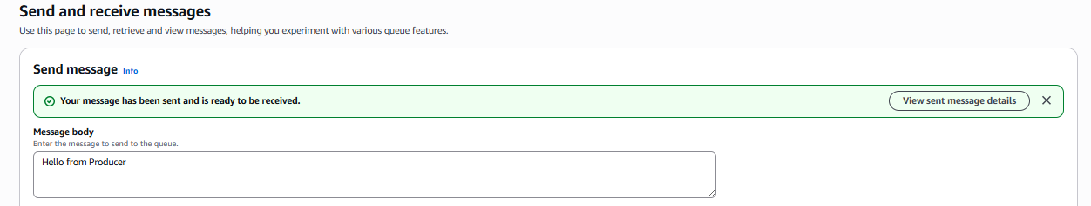

6. Step 5 — Verify Messages in the Queue
Go back to the queue's details.
You can check:
Monitoring → Number of messages available
You should see messages waiting to be processed.
For example:
Messages available: 3
The architecture is now:
Producer
|
| Message 1
| Message 2
| Message 3
▼
┌─────────────────────┐
│ devops-async-queue │
│ │
│ Message 1 │
│ Message 2 │
│ Message 3 │
└─────────────────────┘
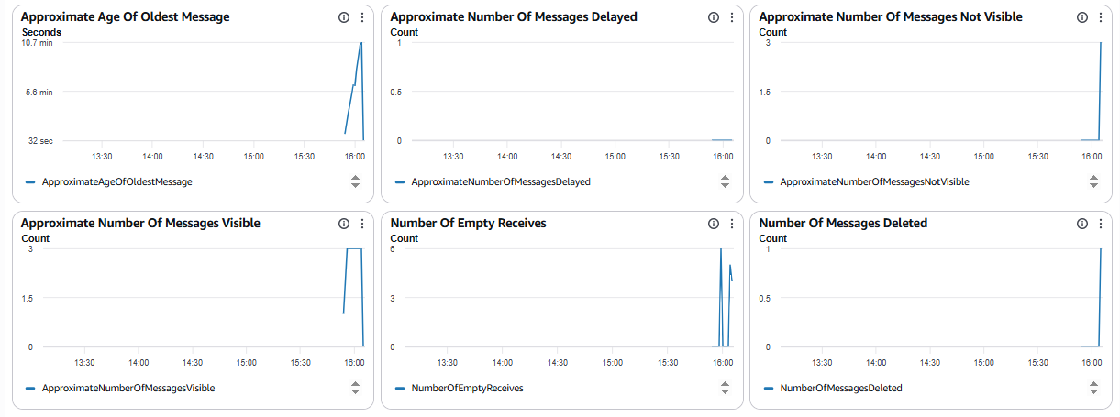

7. Step 6 — Receive Messages
Inside the SQS queue, click:
Send and receive messages
Scroll to:
Receive messages
Click:
Poll for messages
SQS will retrieve the messages.
You should see something like:
Hello from Producer
or:
Order 1001 created
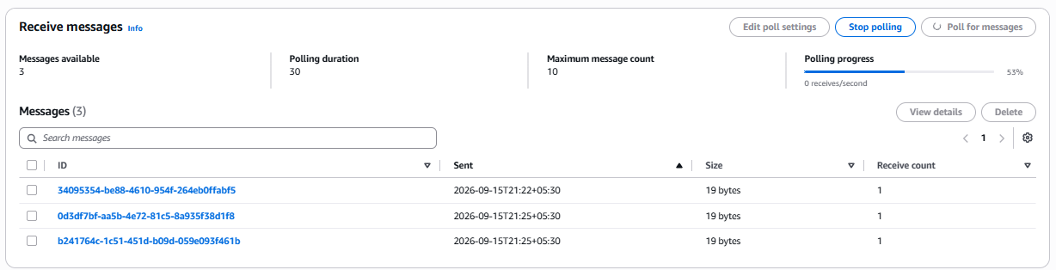

8. Step 7 — Understand Visibility Timeout
This is an important SQS concept.
Suppose:
Visibility Timeout = 30 seconds
When a consumer receives a message, SQS temporarily hides it from other consumers.
SQS Queue
|
| Receive
▼
Message
|
| Hidden for 30 sec
▼
Consumer
If the consumer successfully processes the message, it should delete the message.
If the consumer fails and doesn't delete it, after the visibility timeout the message becomes available again.
This provides reliable asynchronous processing.

9. Step 8 — Delete the Processed Message
After successfully processing a message:
Select the message and click:
Delete
The message is permanently removed from the queue.
For example:
Before processing:

Queue:
Message 1
Message 2
Message 3

↓

Consumer processes Message 1

↓

Delete Message 1

↓

Queue:
Message 2
Message 3

10. Step 9 — Test Asynchronous Processing
Now perform this sequence.

Producer
Send:
Order 1001 created
The producer doesn't need to wait for the consumer.
Producer
|
| Send
▼
SQS
The message remains in SQS until a consumer processes it.
Later:
SQS
|
| Receive
▼
Consumer
|
| Process
▼
Delete message
This is asynchronous processing.

Important SQS Components
Component | Purpose
Producer | Sends messages
SQS Queue | Stores messages
Consumer | Receives/processes messages
Visibility Timeout | Temporarily hides received message
Message Retention | Controls how long SQS keeps unprocessed messages
Receipt Handle | Used to delete a received message
Dead-Letter Queue | Stores messages that repeatedly fail

Final Architecture
PRODUCER
|
| Send Message
▼
┌─────────────────────┐
│ Amazon SQS │
│ │
│ Order 1001 │
│ Order 1002 │
│ Order 1003 │
└──────────┬──────────┘
|
| Receive Message
▼
CONSUMER
|
| Process
▼
Delete Message

Expected Result
You have successfully implemented:
Producer → SQS Queue → Consumer → Message Processing
The key point to remember for interviews is:
Amazon SQS decouples producers and consumers. The producer can send a message to the queue without waiting for the consumer to process it. The consumer retrieves the message when it is ready.

Real-time DevOps example
E-commerce Application
|
| Order Created
▼
SQS
|
| Asynchronous
▼
Order Processing Service
|
▼
Payment / Inventory / Notification
This prevents the main application from becoming dependent on the immediate availability or speed of downstream services.
Files, images, and data analysis are unavailable until usage resets at 10:11 PM. Continue chatting with text only, or upgrade for more access.

Architecture Diagram
Customer Orders
│
▼
+---------------+
| OrderQueue |
| (Amazon SQS)|
+---------------+
│
Receive & Process Messages
▼
Worker/Application
│
Processing Fails (3 Times)
▼
+---------------+
| OrderDLQ |
| (Dead Letter) |
+---------------+

2. AWS MQ
What is AWS MQ?
AWS MQ is a fully managed message broker service that supports open-source message brokers:
- Apache ActiveMQ
- RabbitMQ
It allows organizations to migrate existing messaging applications to AWS without changing application code.

Why AWS MQ?
Instead of managing your own broker servers, AWS handles:
- Installation
- Updates
- Monitoring
- Backups
- High Availability

Architecture
Producer

↓

AWS MQ Broker

↓

Consumer

Supported Brokers
Apache ActiveMQ
Supports
- JMS
- AMQP
- MQTT
- STOMP
- OpenWire

RabbitMQ
Supports
- AMQP
- MQTT
- STOMP

Features
- Fully Managed
- Multi-AZ Deployment
- Automatic Backups
- Monitoring using CloudWatch
- SSL Encryption
- IAM Integration
- High Availability

Deployment Modes
Single Instance
Development
Testing

Active/Standby
Production
High Availability

Security
- IAM Authentication
- Security Groups
- SSL/TLS Encryption
- KMS Encryption

Monitoring
CloudWatch provides:
- CPU Utilization
- Memory
- Connections
- Message Count

Advantages
- No infrastructure management
- Automatic patching
- Supports existing applications
- High Availability
- Easy migration

Limitations
- More expensive than SQS
- Requires broker management concepts
- Lower scalability compared to SQS

Real-Time Use Cases
- Banking Systems
- ERP Applications
- Healthcare Applications
- Retail Applications
- Legacy Enterprise Applications
Amazon MQ vs Amazon SQS
Amazon MQ Amazon SQS
Managed message broker Managed message queue
Supports JMS, AMQP, MQTT, STOMP AWS proprietary API
Best for legacy enterprise applications Best for cloud-native/serverless applications
Applications connect to the broker Applications read/write directly to the queue
Stateful Serverless and highly scalable
TASK : Implement Amazon MQ (ActiveMQ) for Enterprise Messaging

Objective
Learn how to create and configure an Amazon MQ broker, connect to the broker using the ActiveMQ web console, create a queue, send and receive messages, and monitor the broker using Amazon CloudWatch.

Scenario
A company named ABC Finance Ltd. has a legacy application that uses Apache ActiveMQ for processing financial transactions. The company wants to migrate its messaging infrastructure to AWS without changing the application code.
As an AWS Cloud Engineer, your task is to deploy an Amazon MQ (ActiveMQ) broker and verify that it can send and receive messages.

Prerequisites
- AWS Account
- IAM user with Amazon MQ permissions
- Amazon VPC with at least one subnet
- Security Group
- Web browser
- Basic networking knowledge

Architecture
Legacy Application
│
│ Publish Messages
▼
+-----------------------+
| Amazon MQ Broker |
| (ActiveMQ) |
+-----------------------+
│
│ Consume Messages
▼
Consumer Application

Task Requirements
Part 1: Create an Amazon MQ Broker
- Sign in to the AWS Management Console.
- Navigate to Amazon MQ.
- Click Create broker.
- Select Apache ActiveMQ.
- Choose Single-instance broker (for a low-cost lab).
- Broker name:
FinanceBroker
- Engine version: Use the latest available.
- Instance type:
mq.t3.micro
- Deployment mode:
Single-instance
- Create an administrator username and password.
- Choose the default VPC.
- Select one subnet.
- Attach an existing security group (or create one).
- Click Create broker.
Expected Outcome:
- Broker status changes to Running.
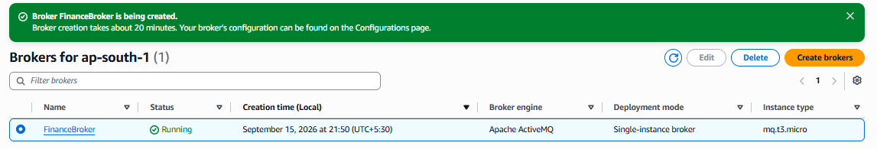

Part 2: Configure the Security Group
Edit the broker's security group to allow access from your public IP address.
Add inbound rules such as:
Type | Port | Source
ActiveMQ Web Console (HTTPS) | 8162 | Your Public IP
OpenWire | 61617 | Your Public IP (optional, if testing clients)
Expected Outcome:
- You can securely access the broker management interface. 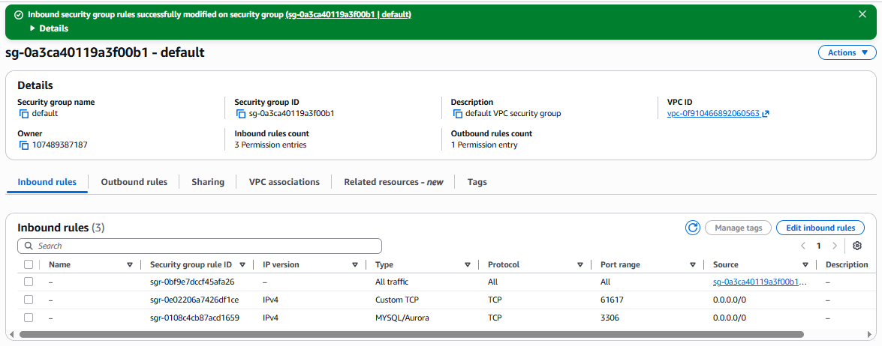

Part 3: Access the ActiveMQ Web Console
- Open your broker details.
- Copy the Web Console URL.
- Open it in a browser.
- Log in with the administrator credentials created earlie
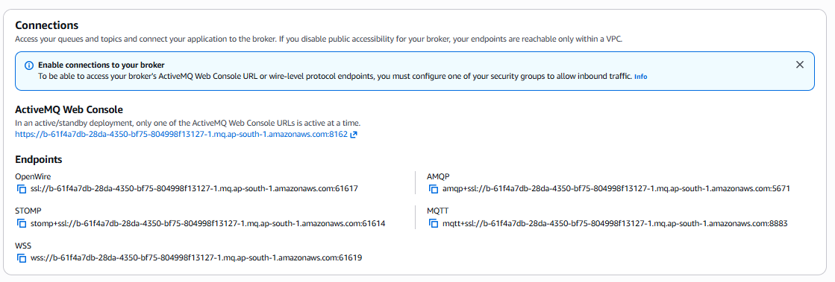

Expected Outcome:
- The ActiveMQ administration dashboard opens successfully.

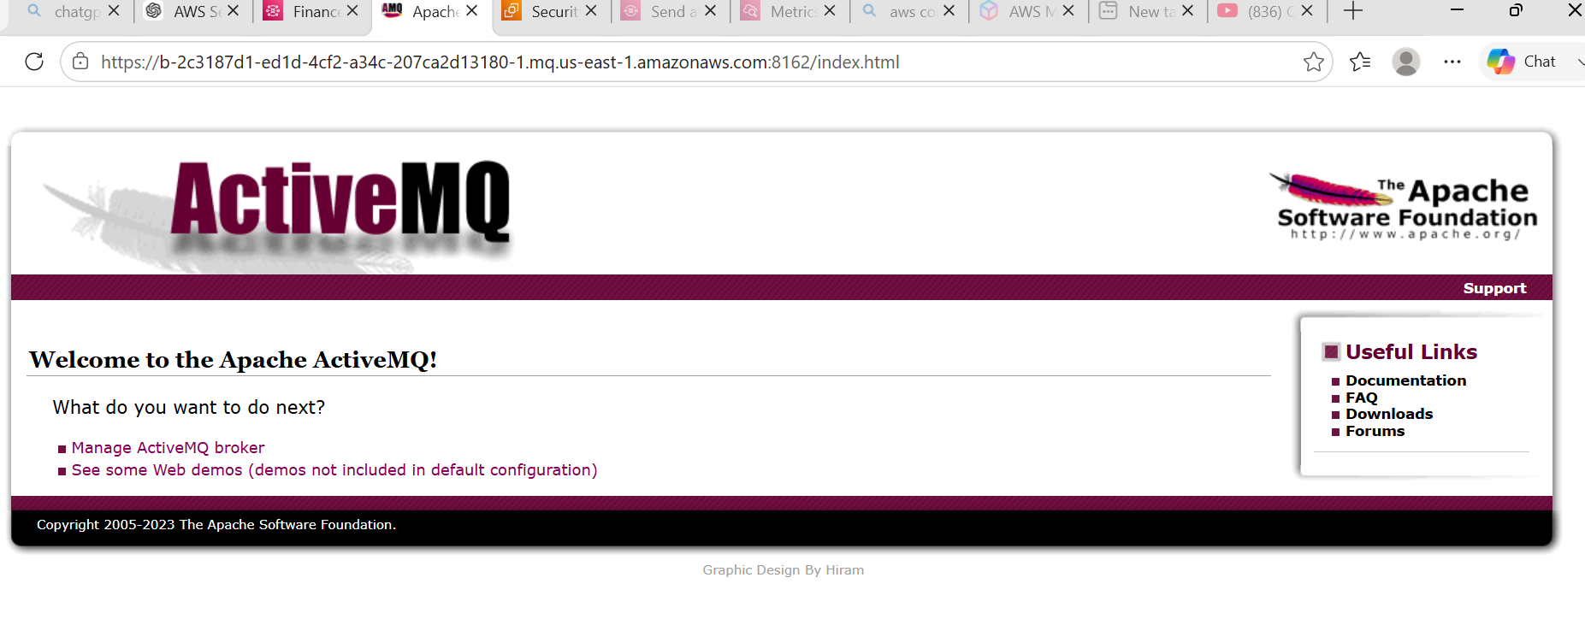

Part 4: Create a Queue
- In the ActiveMQ Web Console, go to Queues.
- Create a queue named:
FinanceQueue
- Save the configuration.
Expected Outcome:
- A queue named FinanceQueue is create
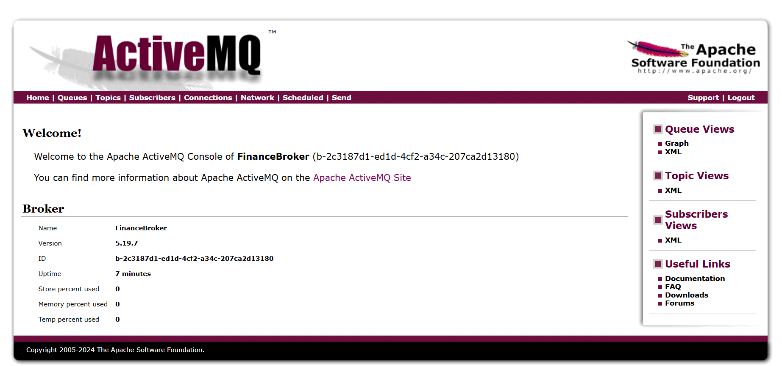

Part 5: Send Test Messages
- Open FinanceQueue.
- Send the following sample messages:
Transaction ID: TXN1001
Amount: ₹5000
Status: Pending
Transaction ID: TXN1002
Amount: ₹12000
Status: Pending
Transaction ID: TXN1003
Amount: ₹8500
Status: Pending
Expected Outcome:
- The messages are stored in the queue.

Part 6: Receive Messages
- Use the ActiveMQ Web Console (or a supported client such as JMS/OpenWire if available).
- Browse the FinanceQueue.
- Verify that all three messages are present.
- Consume the messages.
Expected Outcome:
- Messages are successfully processed and removed (depending on the consumer configuration).
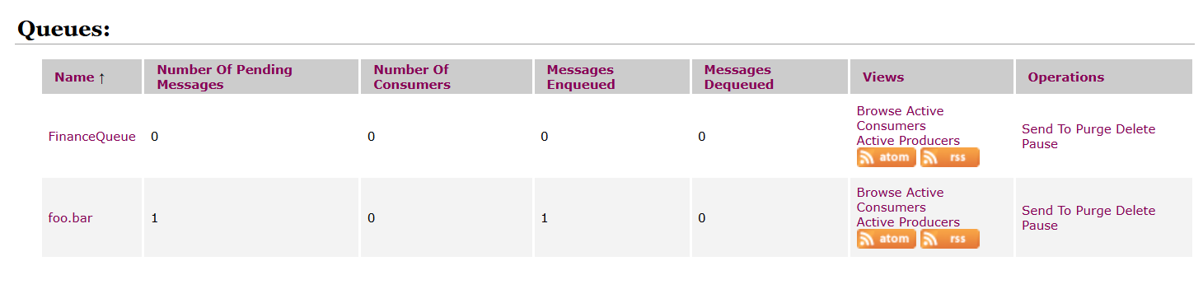

Part 7: Monitor the Broker
- Open Amazon CloudWatch.
- Navigate to Metrics.
- Select Amazon MQ.
- Monitor the following metrics:
  - CPU Utilization
  - Memory Usage
  - Current Connections
  - Queue Size
  - Messages Enqueued
  - Messages Dequeued
Expected Outcome:
- Broker metrics are visible and reflect messaging activity.

Part 8: Restart the Broker
- Open the broker details.
- Restart the broker.
- Wait until the broker returns to the Running state.
- Verify that you can reconnect to the web console.
Expected Outcome:
- The broker restarts successfully and resumes normal operation.

TASK: Create an Amazon MQ (ActiveMQ) Broker and Test a Queue

Objective :
To create a simple Amazon MQ ActiveMQ broker, create a queue, and send/receive a test message using the ActiveMQ Web Console.
Flow:
ActiveMQ Broker
|
v
test.queue
↙ ↘
Send Receive
Message Message

Prerequisites :
- AWS Account
- AWS Console access
- IAM permissions for Amazon MQ
- AWS Region, for example:
ap-south-1 (Mumbai)
- VPC and subnet
- Security Group
- Basic knowledge of AWS networking

Step-by-Step Implementation

Step 1 — Open Amazon MQ
Login to AWS Console.
Search for:
Amazon MQ
Go to:
Amazon MQ → Brokers
Click:
Create broker

Step 2 — Select ActiveMQ
Under Engine options, select:
ActiveMQ
Choose:
ActiveMQ Classic
For this simple lab, select:
Deployment mode:
Single-instance broker
Click Next.

Step 3 — Configure Broker
Enter:
Broker name:
simple-activemq
Select a supported small broker instance type available in your region.
For example:
mq.t3.micro
The exact instance types available can vary by AWS region.

Step 4 — Create Username and Password
Under Users, create an administrator user.
Example:
Username: mqadmin
Password: YourStrongPassword
Remember these credentials because you will use them to access the ActiveMQ console.
Click Next.

Step 5 — Configure Networking
Select your:
VPC
Example:
MY-VPC
Select the required subnet.
For a simple lab, use a subnet where you can establish connectivity to the broker.

Step 6 — Configure Security Group
Create/select a Security Group.
Example:
activemq-sg
Allow the required ActiveMQ management/client ports only from your trusted client IP or security group.
For example, depending on the endpoint/protocol shown for your broker:
TCP 8162 → ActiveMQ Web Console
TCP 61617 → Secure OpenWire client connection
Use the actual ports shown in your Amazon MQ broker details; don't open unnecessary ports to 0.0.0.0/0.

Step 7 — Create the Broker
Review the configuration.
You should have:
Broker:
simple-activemq

Engine:
ActiveMQ

Deployment:
Single-instance

User:
mqadmin
Click:
Create broker

Step 8 — Wait for the Broker
Go to:
Amazon MQ
→ Brokers
→ simple-activemq
Initially you may see:
Creation in progress
Wait until:
Status: Running

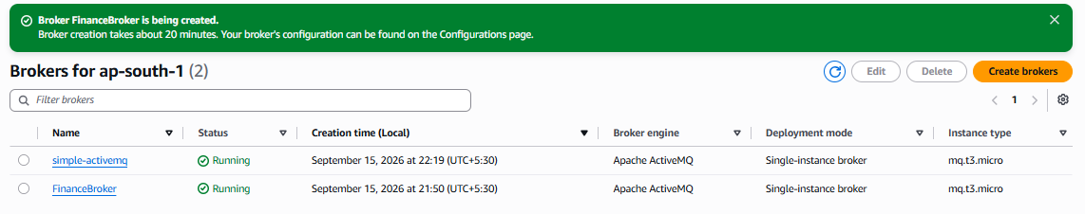

4. Open ActiveMQ Web Console

Step 9 — Get the Web Console URL
Open:
simple-activemq
Look under Endpoints.
Find the ActiveMQ Web Console endpoint.
It will look similar to:
https://b-ad0da805-5cd8-41d2-9540-20fb3a531931-1.mq.ap-south-1.amazonaws.com:8162
Open that endpoint in your browser.
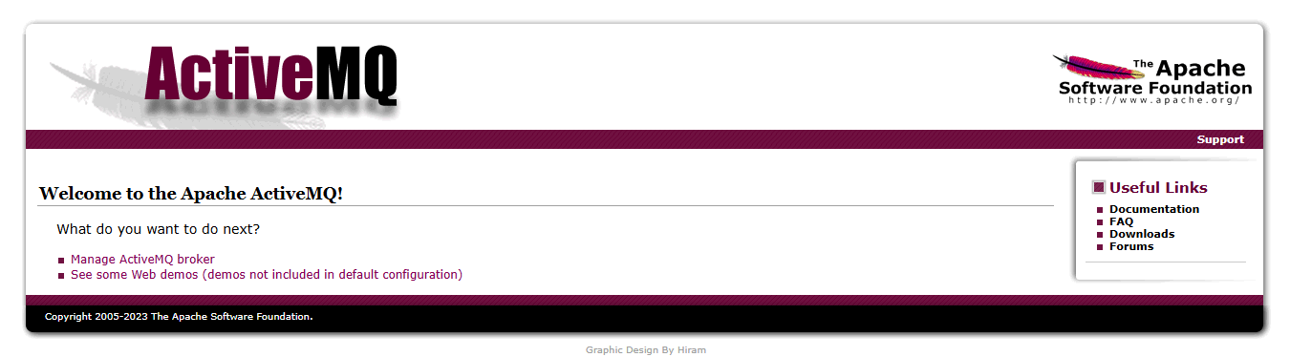

Step 10 — Login
Enter the credentials created earlier:
Username:
mqadmin

Password:
YourStrongPassword
You should now see the ActiveMQ Web Console.
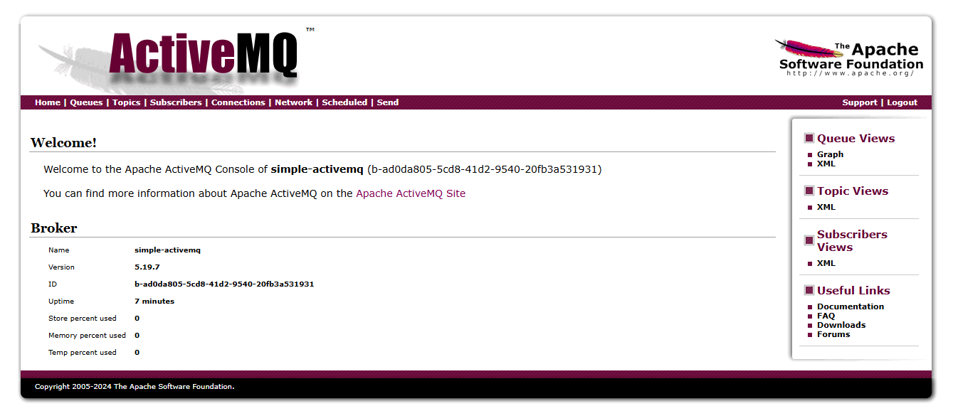

5. Create a Test Queue

Step 11 — Go to Queues
In the ActiveMQ console, go to:
Queues
Create/use a queue named:
test.queue
The queue is where messages will be temporarily stored.

6. Send a Message

Step 12 — Send Test Message
Open:
test.queue

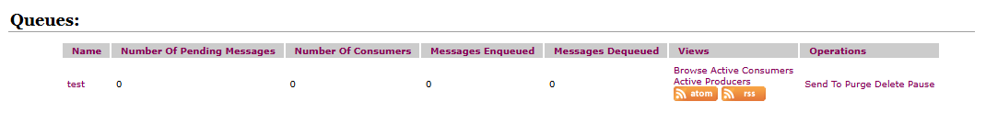
Choose the option to send a message.
Enter:
Hello from Amazon MQ
Click Send.

7. Verify the Message

Step 13 — Check Queue
Check the queue statistics.
You should see something similar to:
Queue: test.queue

Messages:
1

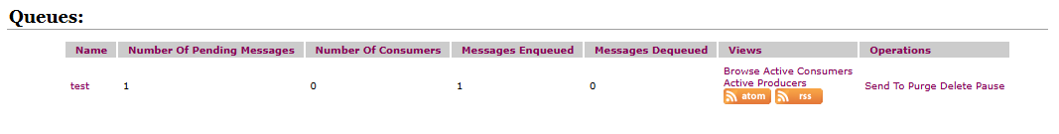
This means the message was successfully placed in the queue.

8. Receive the Message

Step 14 — Consume the Message
Use the queue's browse/consume functionality available in the ActiveMQ console.
You should see:
Hello from Amazon MQ
After successful consumption/acknowledgement, the available message count should decrease.
Before:
Messages = 1

After:
Messages = 0

9. Final Architecture
AWS
|
+--------------+
| Amazon MQ |
| ActiveMQ |
+--------------+
|
v
+-----------+
| test.queue|
+-----------+
↙ ↘
Send Receive
Message Message

Expected Result
You have successfully:
- Created an Amazon MQ ActiveMQ broker
- Created an ActiveMQ user
- Accessed the ActiveMQ Web Console
- Created test.queue
- Sent a test message
- Received/consumed the message
This is a good beginner-level Amazon MQ lab before moving to a producer/consumer application.

3. AWS Secrets Manager
What is AWS Secrets Manager?
AWS Secrets Manager securely stores
- Passwords
- Database Credentials
- API Keys
- Tokens
- SSH Keys
Secrets are encrypted using AWS KMS.

Why Use Secrets Manager?
Instead of:
password = admin123
Applications retrieve credentials securely:
Application

↓

Secrets Manager

↓

Database

Features
- Automatic Rotation
- Encryption
- IAM Access Control
- Version Management
- CloudTrail Logging
- High Availability

Secret Types
- Database Credentials
- API Keys
- OAuth Tokens
- SSH Keys
- Third-party Credentials

Secret Rotation
Automatically changes passwords.
Supported Databases
- MySQL
- PostgreSQL
- MariaDB
- Oracle
- SQL Server

Security
- AWS KMS Encryption
- IAM Policies
- CloudTrail
- Resource Policies

Advantages
- Secure
- Automatic Rotation
- Centralized Management
- Auditing
- Easy Integration

Limitations
- Additional Cost
- Rotation requires supported services or custom Lambda functions

Real-Time Use Cases
- RDS Password Storage
- API Key Management
- CI/CD Pipelines
- Third-party Service Credentials
- Microservices Authentication
AWS Hands-on Task – AWS Secrets Manager
TASK Securely Manage Database Credentials Using AWS Secrets Manager
Objective
Learn how to create, retrieve, update, and use secrets in AWS Secrets Manager to securely manage sensitive information such as database credentials.

Scenario
Your organization is deploying a web application that connects to a MySQL database. To improve security, the database username and password should not be stored in the application code. Instead, they must be securely stored in AWS Secrets Manager.
As an AWS Cloud Engineer, you need to implement a secure solution for storing and managing these credentials.

Prerequisites
- AWS Account
- IAM user with permissions for AWS Secrets Manager
- AWS Management Console access

Task
Step 1: Create a Secret
AWS Console
↓
Secrets Manager
↓
Store a new secret
Choose
Other type of secret
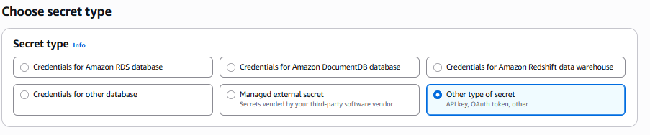
Enter
Key value
username
Password
Secret Name
DatabaseCredentials
Click Next → Store.
Screenshot: Secret Created
Step 2: Open the Secret
Open
DatabaseCredentials
You should see
Username
admin
Password will be hidden.
Screenshot: Secret Details
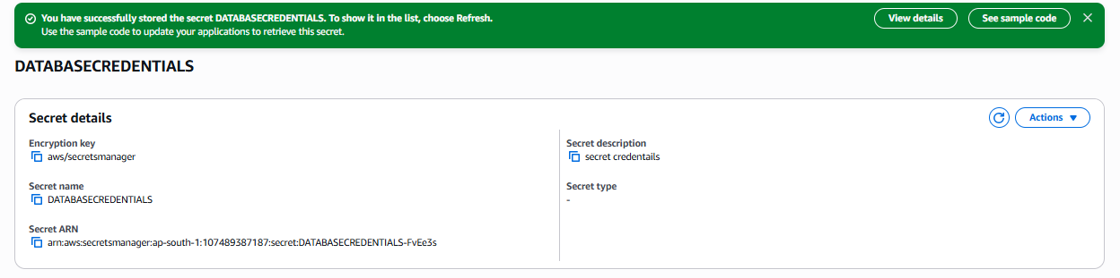
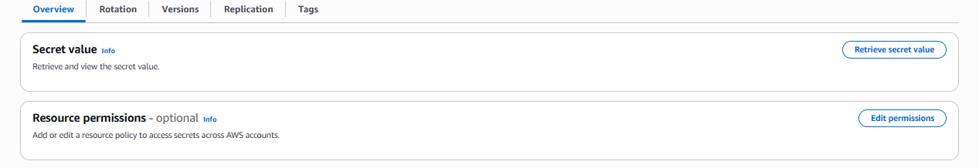
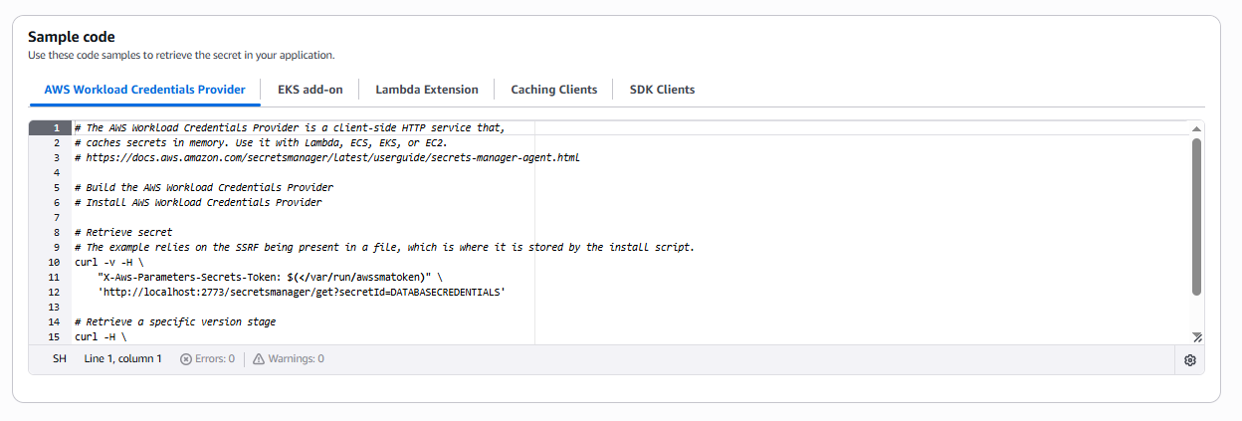
Retrieve Secret from Lambda
Step 1: Find the Lambda Execution Role
1. Open AWS Lambda
2. Click your function (OrderProcessor)
3. Go to Configuration
4. Click Permissions
You will see something like:
Execution role
OrderProcessor-role-abc123
Click the role name.
It opens the IAM Console.
Step 2: Add Secrets Manager Permission
In IAM:
Click
Add permissions
↓
Attach policies
Search for
SecretsManagerReadWrite
Select it
↓
Click
Add permissions
(For this lab, this policy is fine. In production, you'd use a more limited policy.)
Step 3: Go Back to Lambda
Now open
Lambda
→ OrderProcessor
→ Code
Replace the code with:
import boto3
def lambda_handler(event, context):
client = boto3.client('secretsmanager')
response = client.get_secret_value(
SecretId='Maria-DB-Secret'
)
print(response['SecretString'])
return {
'statusCode': 200,
'body': 'Secret Retrieved Successfully'
}
Replace Maria-DB-Secret with your exact secret name if it's different.
Step 4: Deploy
Click the orange
Deploy
button. 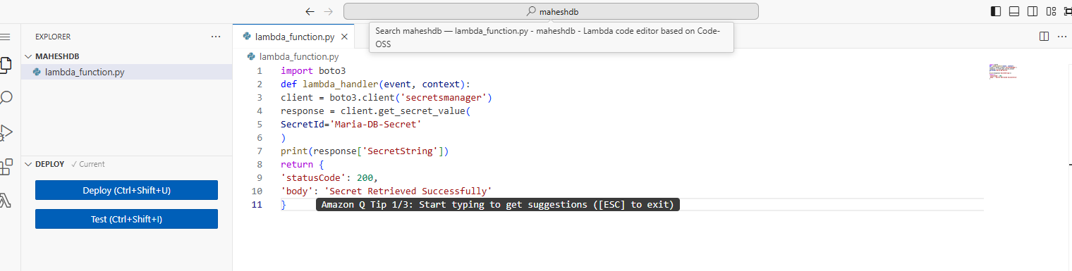
Step 5: Test
Click
Test
↓
Create a new test event.
Name:
TestSecret
Leave the default JSON:
{}
Click
Save
Click
Test
Step 6: Check the Output
If everything is correct, you'll see:
Status: Succeeded
Why Use Secrets Manager?
Hardcoded password:
password = "Password@123"
Problems:
• Anyone with access to the code can see it.
• Changing the password requires updating and redeploying the application

